# Project Report Template

BUILD AN EMPLOYEE TRAVEL APPROVAL APPLICATION FOR CORPORATES

1.Introduction

1.1 Project Description.

The project aim is to provide real-time knowledge for all the students who have basic knowledge Of Salesforce and Looking for a real-time project. This project will also help to those Professionals who are in cross-technology and wanted to switch to Salesforce with the help of This project they will gain knowledge and can include into their resume as well.

1.2 Purpose.

The project aim is to provide real-time knowledge for all the students who have basic knowledge of Salesforce and Looking for a real-time project.

# 2.Problem Definition & Design Thinking.

2.1 Empathy Map.

An empathy map is a widely-used visualization tool within the field of UX and HCI practice

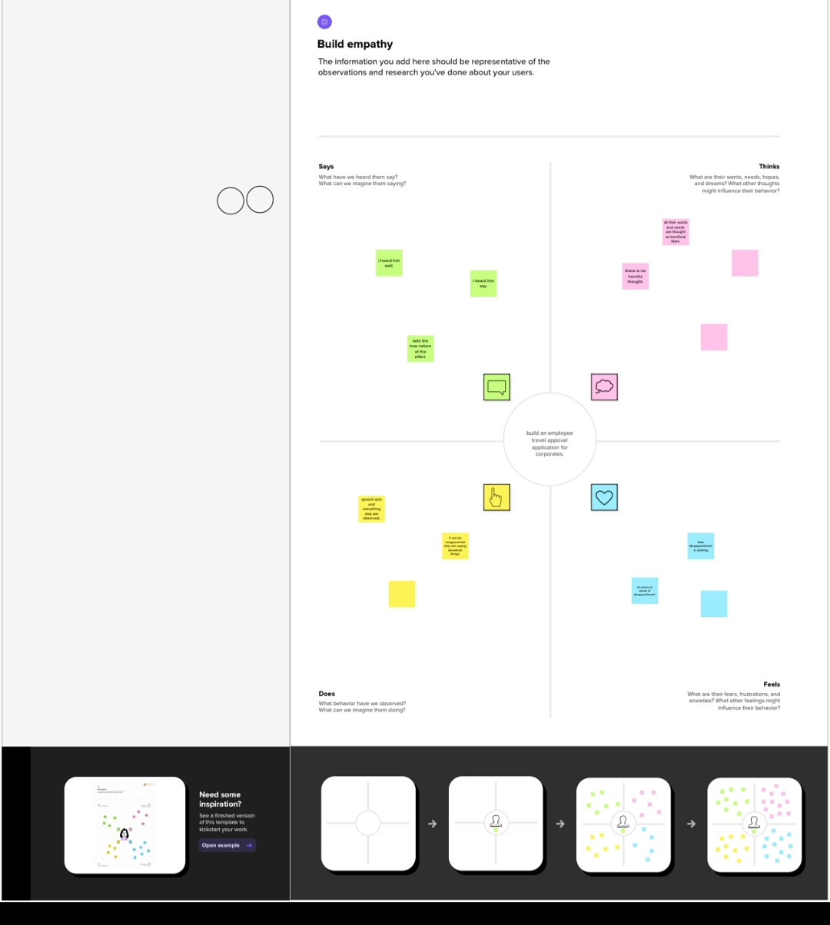

2.2 Brainstorm.

Brainstorming is a group problem-solving method that involves the spontaneous contribution of creative ideas and solutions.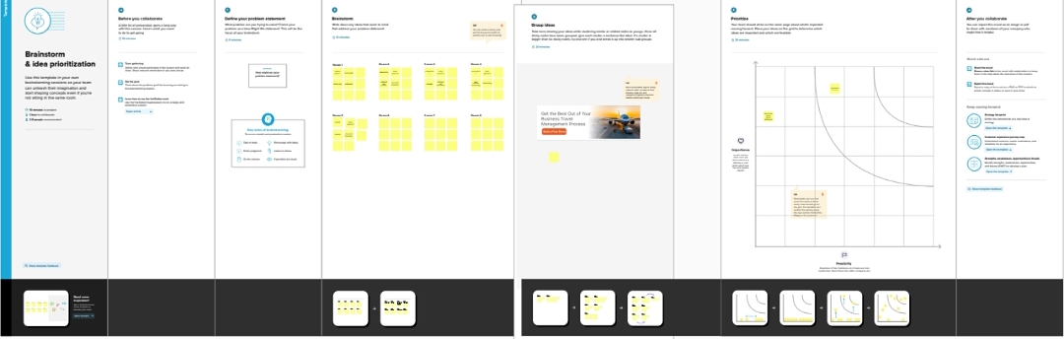.

# 3.RESULT.

## 3.1 Data Mode.

|  |  |
| --- | --- |
| Object name | Field in the object |
| Obj 1 | |  |  | | --- | --- | | Field label | Data Type | | Department | Text | | Travel approval | Auto number | |
| Obj 2 | |  |  | | --- | --- | | Field label | Data type | | Expense item | Text | |

## 3.2 Activity & Screenshot

Activity-1

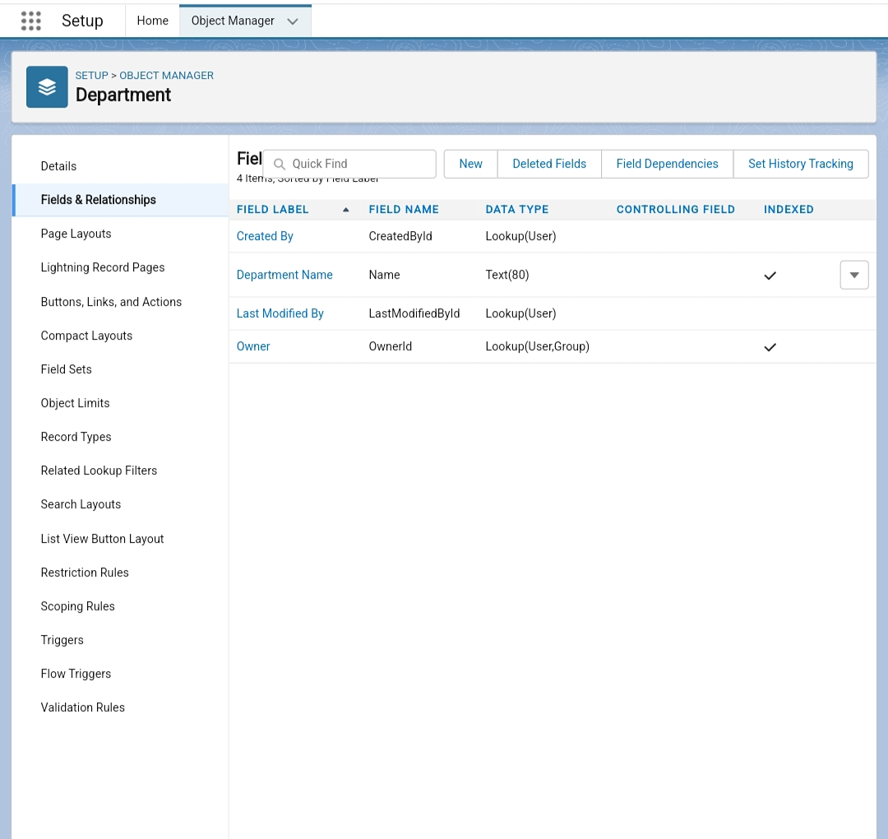

Activity-2

Active-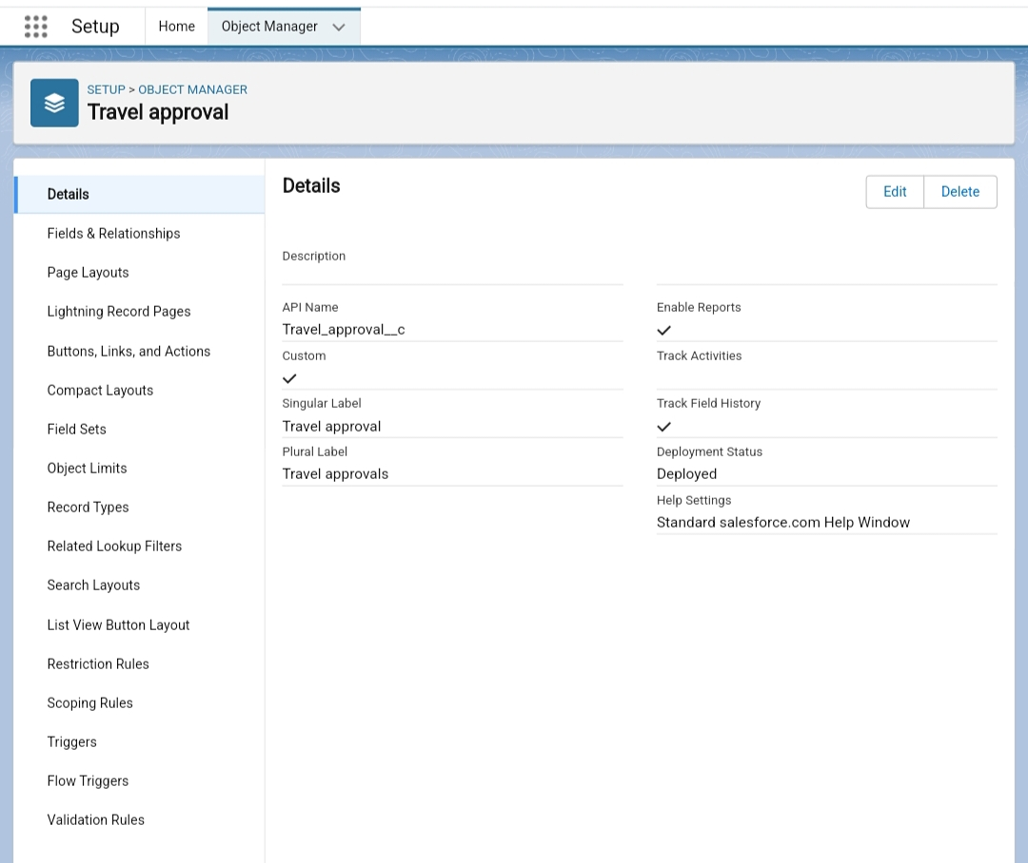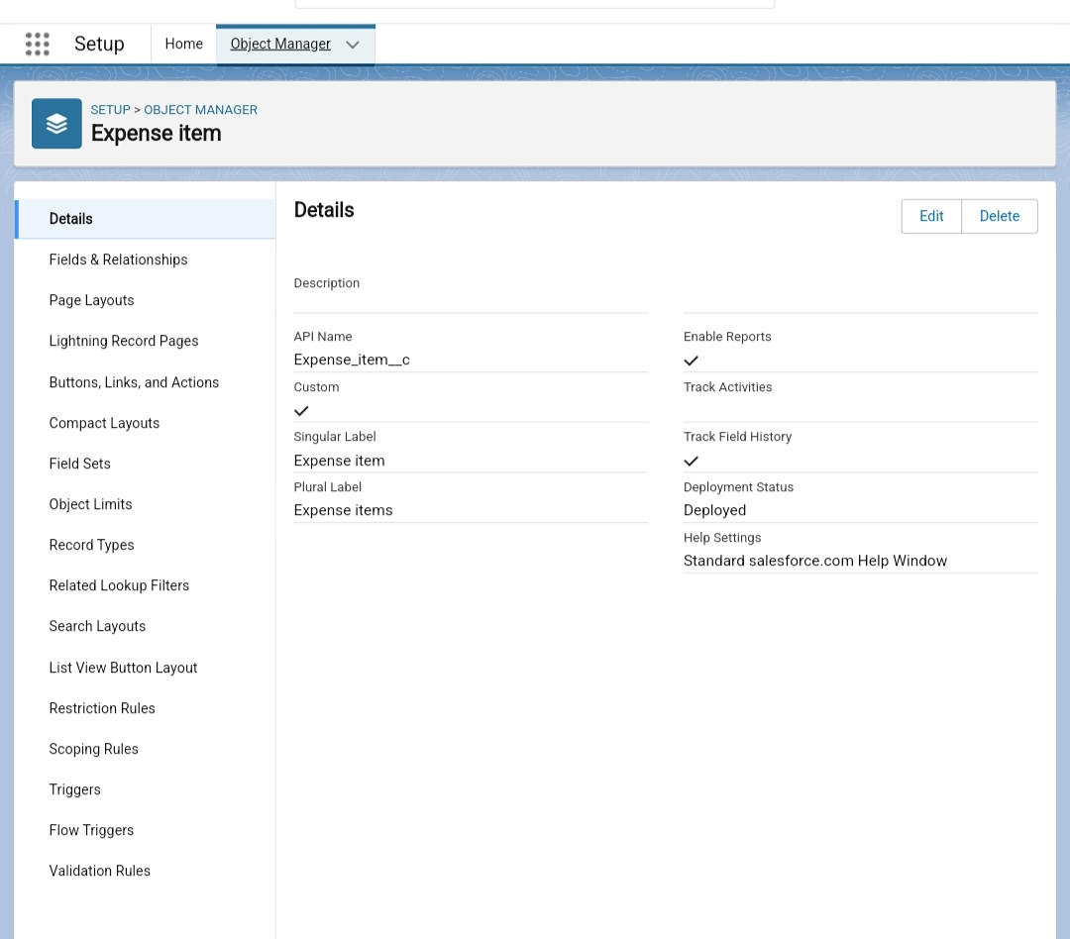3

# 4.Trailhead Profile Public URL.

Team Lead - https://trailblazer.me/id/naveen3690

Team Member 1 – https://trailblazer.me/id/cnaveen36

Team Member 2 – https://trailblazer.me/id/prabha19

Team Member 3 – https://trailblazer.me/id/rajkm10

Team Member 4- https://trailblazer.me/id/rramesh116

# 5.ADVANTAGES & DISADVANTAGE.

## 5.1 Advantages.

•Approvals on time. The entire process of planning and managing a trip is a long and stressful process. …

•Customize approval workflows. The approval process can differ from company to company. …

•Increase compliance and reduce costs. …

•Faster process.

## 5.2 Disadvantage.

•More Networking Opportunities. …

•To Meet with Prospective Clients. …

•It Can Be Expensive. …

•Travelling Can Be Stressful. …

•A High Level of Unproductivity. …

•It Can Affect Health and Fitness. …

•Missing Friends and Family. …

•Final Thoughts.

# 6.APPLICATIONS.

✓ About the sample application.

✓ Prerequisites.

✓ Installing the sample Application.

✓ Starting the sample Application.

✓ Logging inasan employee for requesting a business trip.

✓ Approving a travel request.

# 7.CONCLUSION.

Salesforce is your customer success platform, designed to help you sell, service, market, analyze,And connect with your customers.

# 8.FUTURE SCOPE.